During most of April and May we sampled with two continuous-reading instruments, side-by-side for diesel particulate, using a heavily trafficked area of Morgantown, prior to work on a Marcellus shale gas well being drilled, south of the sampling area. This was done to obtain a comparison of the two instruments as well as providing some background data for sampling the well site once activity started. Results (Figures 1a and 1b) showed that the PM2.5 concentrations were well below the National Ambient Air Quality Standards for a 24 hour sampling time (0.035 mg/m³) with concentrations in April being slightly less than those in May (0.007 versus 0.014 mg/m³).
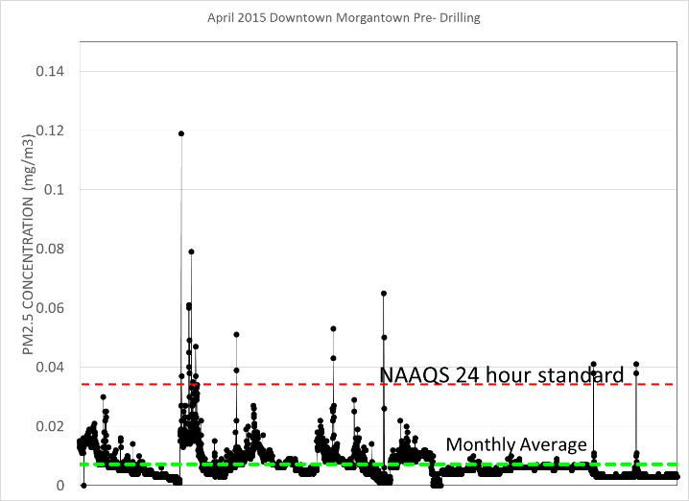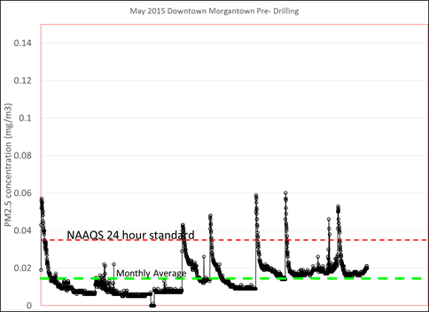
a. b.
Figure 1. PM2.5 dust sampling results using a TSI Dust Track II direct-reading, light-scattering monitor for April (a.) and May (b.) 2015. The NAAQS 24 hour standard for PM2.5 dust is 0.035 mg/m³. Average actual PM2.5 dust concentration for April was 0.007 mg/m³ and for May was 0.014 mg/m³.
Traffic was video recorded and is being analyzed to determine the number of autos and the number of diesel trucks passing by the monitors averaged of 15 minute periods of time to determine if a correlation between traffic and dust levels could be detected. We were also interested in knowing whether or not there would be a correlation between particle mass and particle number concentration. Ultrafine (particles less than 0.1 micrometer in diameter) Particle number concentration has been hypothesized to be a better measure of acute toxicity of diesel particulate than particle mass but is more difficult and more expensive to measure. Finding a correlation between either the traffic density or the particle mass measurements would allow for less expensive techniques to be used to monitor the diesel particulate. Even if only in a qualitative way could the diesel particle number be measured it could still be used to do real time control of activity at a well site, giving trend data that might allow simple control measures to be taken.
Particle number concentrations taken side-by-side with the particle mass measurement devices and within 30 meters of a roadway are shown in Figures 2a. and 2b. The trends in the particle number data, however, are not like the trends in the mass data, showing a higher monthly average for April rather than May (10,000 particles per cc versus 8,000 particles per cc). Weather data was also taken during each of the sampling periods and the effects of weather, traffic density and partitioning of vehicles by type (diesel versus gasoline) are being considered in a multiple regression model which should be done in time for the July report.
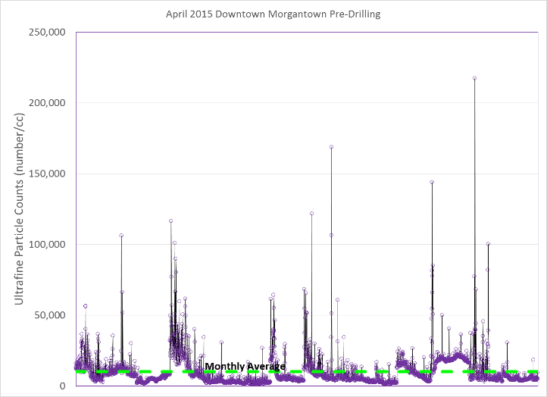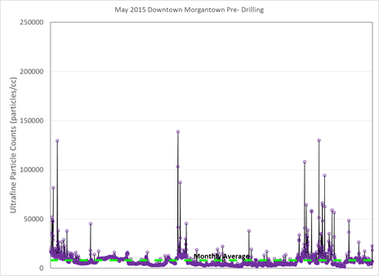
a. b.
Figure 2. Ultrafine particle number concentration measured using a TSI P-track particle counter for April (a.) and May (b.) 2015. Average monthly concentration was approximately 8,000 particles per cc for April and 10,000 particles/cc for May. There is no NAAQS standard for ultrafine particles but the literature suggests that at approximately 8,000 particle/cc exacerbation of pediatric asthma has been seen in some populations as well as exacerbation of cardiovascular disease. Levels such as those seen in April and May could therefore contribute to an enhanced background of disease, unattributable to PM2.5 releases from traffic. If unaccounted for, ultrafine concentration fluctuations could lead to an assumption that increases in drilling operations and an assumed increase in releases from the drilling are responsible for the fluctuations in those diesases.

